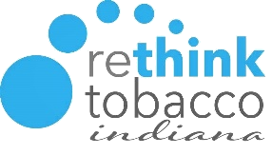

University of Massachusetts
Tobacco Treatment Specialist (TTS) Core Training Hosted by Rethink Tobacco Indiana
November 9-11 2022| 8:30 – 4:30 PM ET
Virtual Training

TRAINING OVERVIEW
The Tobacco Treatment Specialist Core Training is an intensive 3-day evidence-based training program. The program is designed for persons who want to deliver moderate to intensive tobacco treatment services within health care or community setting. The curriculum addresses a set of core competencies defined by the Association for the Treatment of Tobacco Use and Dependence. The University of Massachusetts (UMass) Tobacco Treatment Specialist Training and Certification Program is accredited by the Council for Tobacco Treatment Training Programs (CTTTP).

THE TTS CORE TRAINING INCLUDES TWO COMPONENTS: TTS PART 1 (ONLINE) AND TTS PART 2 (LIVE VIRTUAL)

TTS CORE TRAINING | TTS  Part 1  (online) | This is an 8–10 hour online training course that must be completed BEFORE attending the live 3-day TTS Part 2 training.  Part 1 covers the determinants of tobacco use disorder, including biological, psychological, and social aspects; physical and behavioral health impact of tobacco use; and best practices for systems to support treatment of tobacco use disorder.
 | TTS  Part 2  (live virtual) | This is an intensive 3-day, virtual, evidence-based training program which will be held on May 18-20, 2022.  TTS Part 2 will cover pharmacotherapy; counseling skills such as motivational interviewing; cognitive and behavioral strategies to assist tobacco users in quitting; and intake, assessment, and treatment planning.
What is a Tobacco Treatment Specialist (TTS)?
A Tobacco Treatment Specialist is a professional who possesses the skills, knowledge, and training to provide effective, evidence-based interventions for tobacco and nicotine dependence across a range of intensities. TTSs are trained to develop individualized treatment plans using evidence-based treatment strategies and facilitate client involvement in treatment.
Training Prerequisite:
- Prior to attending the 3-day TTS Part 2, all participants must successfully complete the TTS Part 1 online course by November 4th, 2022. After registering for the training, a link will be emailed to you with instructions on how to register and access this prerequisite.
- Participants must be tobacco-free (including e-cigarettes) for six months prior to the training.

VIRTUAL TRAINING REQUIREMENTS
The TTS Core Training will be held virtually using Zoom video conferencing. Participants are asked to download and utilize zoom client for the training, rather than joining by web browser. You may need to seek approval from your organization’s IT administrators prior to downloading.
Participants are asked to have good/stable internet connection for the duration of the training. If you are working from home and do not have stable internet connection, please consider other settings which you can attend the training with stable internet connection.
This training is interactive and requires all participants to share their webcam throughout the duration of the training. If your computer or laptop does not have webcam capability, please utilize a mobile device or tablet which you can share your webcam. For example, you may join the training and view the training slides on your laptop, but also be joined into the meeting on your cellphone to share your webcam (we want to see your smiling faces!).
We also ask that you have the capability to speak/have audio over your computer, mobile device, or tablet. If it is helpful, consider utilizing a headset or headphones for best audio quality.
Participants must be present for the entire training. This means there should be no other work or home responsibilities for the entire training course.

HELPFUL RESOURCES FOR ZOOM VIDEO CONFERENCING
DOWNLOAD ZOOM CLIENT/APP | - Download here
ZOOM SUPPORT CENTER | - Click here for Frequently Asked Questions
HOW TO SHARE YOUR SCREEN | - Overview video
HOW TO USE BREAKOUT ROOMS | - Overview video
ONLINE MEETING ETIQUETTE FOR ATTENDEES (ARTICLE) | - Helpful tips

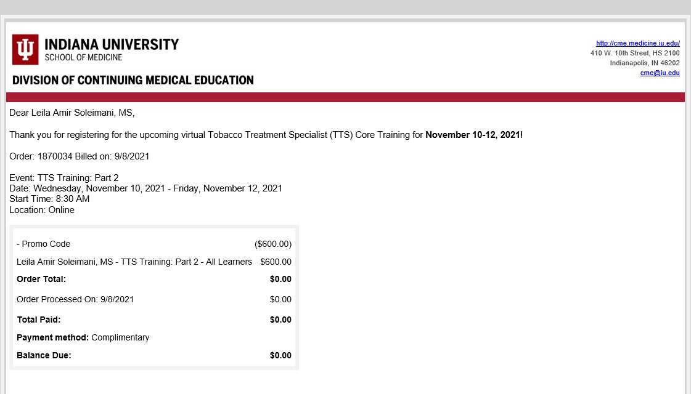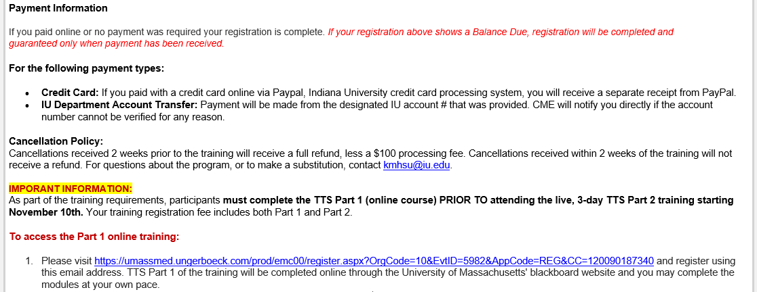
SAMPLE CONFIRMATION EMAIL

REGISTERING AND ACCESSING TTS PART 1 ONLINE COURSE
After registering for the TTS Training, you will receive a confirmation email from the IU School of Medicine Division of Continuing Medical Education (ce@iu.cloud-cme.com). This confirmation email contains important instructions on how to access the TTS Part 1 online course.
Please see the sample email below. Under the “Important Information” section, are steps on how to register and access the TTS Part 1 online course. Your training registration fee includes both TTS Part 1 and Part 2. Please note: TTS Part 1 must be completed by November 4th, 2022 (prior to the live, three-day TTS Part 2 training).

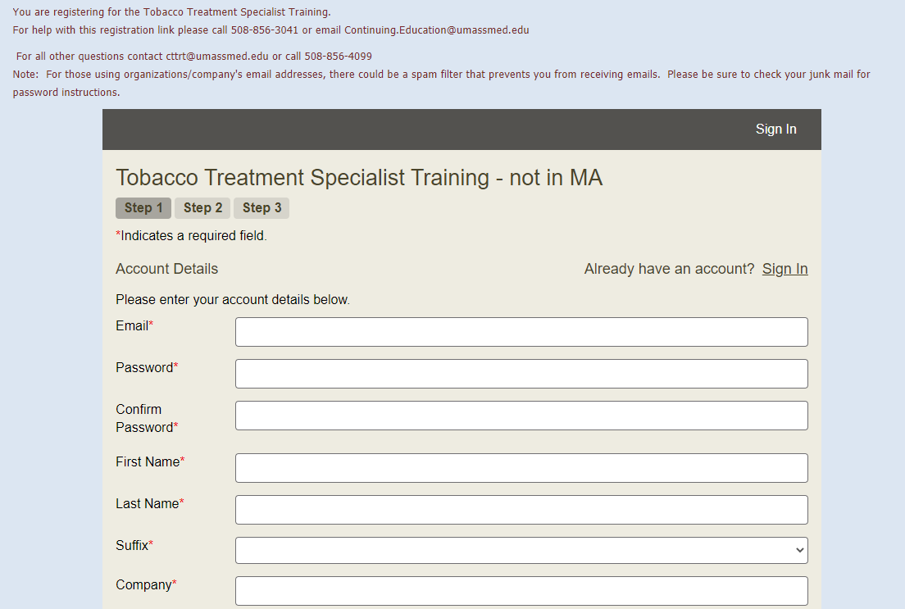

TTS PART 1 REGISTRATION STEP-BY-STEP INSTRUCTIONS
STEP 1: Using the unique link provided in your registration confirmation email, register for the TTS Part 1 online training using the SAME email address used for training registration. This will bring you to the webpage pictured below.
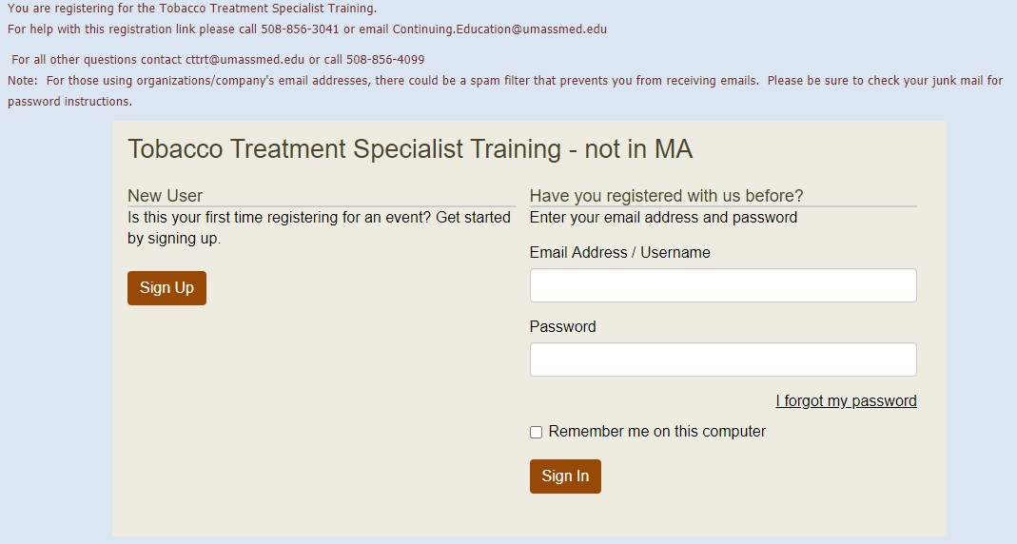

STEP 2: Click on the “Sign up” button located on the left side of the menu. You will be taken to the Tobacco Treatment Specialist Training – not in MA registration page. Please complete all the required registration fields. Again, be sure to use the same email address and double check the spelling of your information as this cannot be changed.

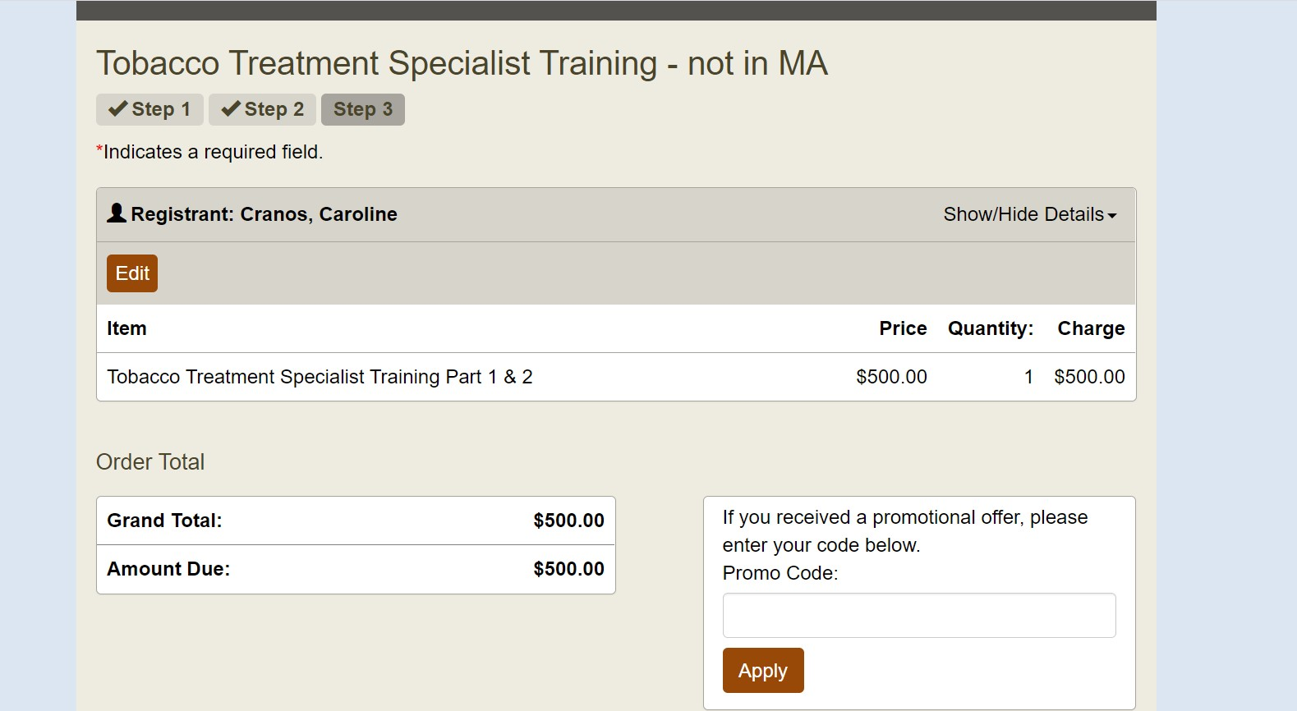

STEP 3: After you have entered your information, click the “Next” button at the bottom of the screen. After clicking “next”, you will see the below screen.

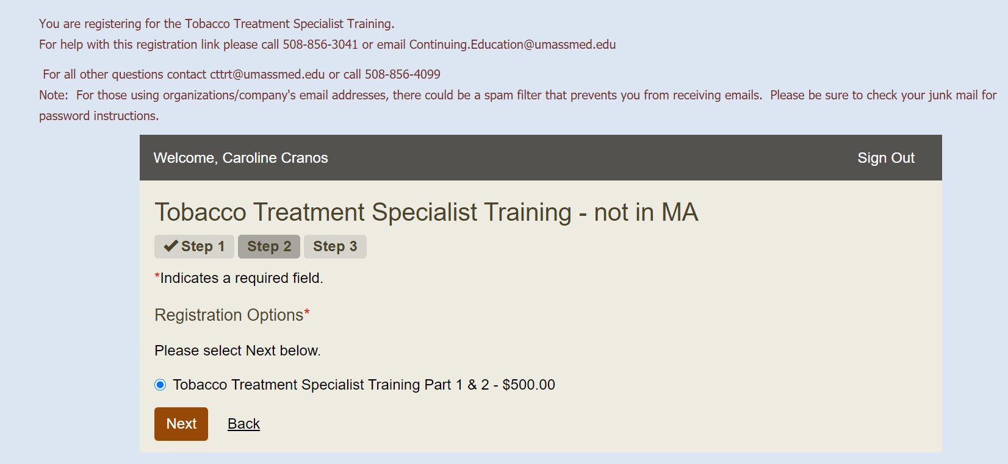

STEP 4: Again click the “Next” button to proceed to the final registration page (you will not be charged
$500). You will then see the below on your screen.

STEP 5: Lastly, enter the promo code provided to you in your initial training confirmation email in the promo code box, then click “apply”. This will reduce the balance $0.00. Then click the “Submit/Finish” button to complete your TTS Part 1 registration.

After you complete your TTS Part 1 registration:
Within 90 minutes you will receive an email from continuing.education@umassmed.edu to the email address at which you registered. This email will provide you with important information you will need to access the Part 1 course in Blackboard. Please double check that your email address is correct when creating your account. (If you do not receive the email, please check your spam or junk email folder before contacting UMass).

The TTS Part 1 training modules may be completed at your own pace via blackboard, but must be completed by Friday, May 13th. If you need help or have issues with your blackboard account, please contact Caroline Cranos or the UMass helpdesk at (508) 856–8643 or helpdesk@umassmed.edu. For after hours and weekend support, please call (855) 789 –7056.

For additional questions, please contact Debi Buckles at dhudson@iupui.edu or 317-278-2726.

AGENDA
Please try to log onto zoom 15 minutes prior to the start of each day to check-in for attendance and ensure audio and video are working properly. Breakfast and lunch will be on your own, feel free to disable camera and audio during these times.
Wednesday, May 18th

8:30 – 9:15 AM | Introductions and Welcome
9:15 – 10:15 AM | Counseling Skills: Building Rapport with Motivational Interviewing
10:15 – 10:30 AM | Break
10:30 – 12:15 PM | Counseling Skills: Building Rapport with Motivational Interviewing
12:15 – 1:00 PM | Lunch on your own – You may disable camera/audio
1:00 – 2:15 PM | Counseling Skills: Building Rapport with Motivational Interviewing
2:15 – 2:30 PM | Break
2:30 – 3:30 PM | Counseling Skills: Building Rapport with Motivational Interviewing
3:30 – 3:45 PM | Break
3:45 – 4:30 PM | Counseling Skills: Building Rapport with Motivational Interviewing

Thursday, May 19th

8:30 – 10:20 AM | Pharmacotherapy for the Treatment of Tobacco Use Disorder
10:20 – 10:40 AM | Break
10:40 – 12:15 PM | Pharmacotherapy for the Treatment of Tobacco Use Disorder
12:15 – 1:00 PM | Lunch on your own – You may disable camera/audio
1:00 – 2:15 PM | Cognitive and Behavioral Treatment Strategies
2:15 – 2:30 PM | Break
2:30 – 4:30 PM | Cognitive and Behavioral Treatment Strategies

Friday, May 20th

8:30 – 10:00 AM | Intake, Assessment and Treatment Planning
10:00 – 10:15 AM | Break
10:15 – 11:30 AM | Intake, Assessment and Treatment Planning
11:30 – 12:15 PM | Lunch on your own – You may disable camera/audio
12:15 – 1:20 PM | Intake, Assessment and Treatment Planning
1:20 – 1:30 PM | Break
1:30 – 2:45 PM | Intake, Assessment and Treatment Planning
2:45 – 4:30 PM | TTS Exam, National Certificate, General Questions

LEARNING OBJECTIVES

Counseling Skills: Building Rapport with Motivational Interviewing
- Assess readiness to change.
- Define characteristics and process of motivational interviewing.
- Demonstrate the basic skills of motivational interviewing.
- List the categories of change talk.
- Describe how to negotiate an action plan.

Pharmacotherapy for the Treatment of Tobacco Use Disorder
- Describe various types of NRT and Non NRT medications available, how they work & general guidelines for use.
- Describe and apply evidence-based medicine principles to pharmacological treatment for nicotine dependence.
- Explain the anticipated effects of the available pharmacologic treatment in select medical conditions.
- List additional special concerns and issues that affect the choice of pharmacologic treatment.
- Apply knowledge of the use of pharmacotherapy to hypothetical cases.

Cognitive and Behavioral Treatment Strategies
- Explore the integration of MI and CBT in an intensive treatment plan.
- Describe the differences between cognitive and behavioral strategies.
- Learn specific cognitive and behavioral strategies for the pre-cessation, cessation, and relapse prevention phases of treatment.
- Review treatment considerations for priority populations.

Intake, Assessment and Treatment Planning
- Describe the key components of a comprehensive intake process including;demographics, tobacco use, quitting, and medical/psychiatric history, dependence, social, cultural, environmental factors.
- Assess a tobacco user from a bio/psycho/social model
- Identify strengths and potential barriers to treatment.
- Conduct interviews in a manner which advances stage of change and promotesself-efficacy.
- Develop a tailored treatment plan based on the assessment.

TTS Exam and Certificates
- Describe the process for taking the TTS exam and applying for the National Certificate in Tobacco Treatment Practice.

TRAINING INSTRUCTORS

Deborah (Hudson) Buckles, BS, NCTTP
Deborah is the Program Director of the IU Simon Tobacco Treatment Program. Employed by the IU Simon Cancer Center since 1997, the first 13 years of Mrs. Buckles’ career were dedicated to helping individuals overcome tobacco addiction. Since 2008, Mrs. Buckles has dedicated her career to the ReThink Tobacco Indiana project, focused on tobacco cessation systems change in mental health & substance abuse centers across Indiana. In addition, Mrs. Buckles oversees the IU Simon Tobacco Treatment Program that provides tobacco treatment to cancer patients. During Mrs. Buckles’ more than 20 years in the field of tobacco treatment she has coordinated and developed training programs for health care professionals and lay persons across Indiana, worked on multiple research efforts, and been a leader in the state. Mrs. Buckles received her Bachelor of Science degree in Respiratory Therapy and the National Certificate in Tobacco Treatment Practice and is also a Certified-UMass TTS Trainer.
Email: dhudson@iupui.edu Cell: 317-439-2692

Trisha Palencer, LCSW, LCAC, MAC
Trisha Palencer joined IU Health in 2019 to assist in the development of the Addiction Treatment and Recovery Center and currently serves as the program’s Director. Trisha is a licensed clinical social worker and licensed clinical addiction counselor and specializes in the treatment of substance use, depression, anxiety and trauma-related disorders.
Email: tpalencer@IUHealth.org

Karen S. Hudmon, DrPH, MS, RPh, TTS
Dr. Hudmon is Professor of Pharmacy Practice at the Purdue University College of Pharmacy and Clinical Professor at the University of California San Francisco School of Pharmacy. She is a licensed pharmacist and a cancer prevention researcher. She has nearly 30 years of tobacco research experience and has personally provided tobacco cessation training to more than 30,000 health professionals (students and licensed clinicians). She was one of the original authors of the Rx for Change: Clinician-Assisted Tobacco Cessation training program, which has been in existence since 1999 and is used globally to train students and licensed clinicians to apply evidence-based approaches for helping patients quit. Currently, Karen’s research is funded by the NIH and the Indiana State Department of Health. In addition, she is a certified tobacco treatment specialist (TTS) and a
Certified-UMass TTS Trainer. Email: khudmon@purdue.edu

Ashley Jones, PhD, RN, NCTTP
Ashley is passionate about Motivational Interviewing, tobacco treatment in the perinatal population, and supporting others with their own personal and professional growth and development. Dr. Jones received her PhD from the IU School of Nursing at IUPUI where she was a Robert Wood Johnson Foundation Future of Nursing Scholar, was named a Rising Star of Research, and was a recipient of the William M. Plater Civic Engagement Medallion. Her dissertation was titled “Perinatal Smoking and Its Related Factors”. Through her initial research, Dr. Jones found significant associations between perinatal depression and smoking, and identified a highly accurate predictive model for smoking across an 18-month time period. She completed the Tobacco Treatment Specialist training through the University of Massachusetts Medical Center (UMASS) and has received the National Certificate in Tobacco Treatment Practice (NCTTP). She is also actively involved with the Healthy Shelby County Coalition and is currently a member of the community leadership group and the Tobacco Action Group in Shelby County, Indiana. Dr. Jones is a Nurse Supervisor with Nurse-Family Partnership (NFP) at Goodwill Industries of Central & Southern Indiana, located in Indianapolis, IN. There, she leads the smoking cessation continuous quality improvement group, which has been responsible for supporting smoking cessation among the 1000 families enrolled in NFP sites across the state of Indiana. Dr. Jones is a member of the Motivational Interviewing Network of Trainers and is active in providing initial and ongoing coaching and support for the learning and development of MI skills.

Email: ajones.cornerstonertd@gmail.com

CONTINUING EDUCATION
Accreditation

Physicians

In support of improving patient care, Indiana University School of Medicine is jointly accredited by the Accreditation Council for Continuing Medical Education (ACCME), the Accreditation Council for Pharmacy Education (ACPE), and the American Nurses Credentialing Center (ANCC), to provide continuing education for the healthcare team.

Indiana University School of Medicine designates this live activity for a maximum of 18.25 AMA PRA Category 1 Credits™. Physicians should claim only the credit commensurate with the extent of their participation in the activity.
Pharmacist
Indiana University School of Medicine designates this activity for 18.25 ACPE contact hours. Pharmacists should only claim credit commensurate with the extent of their participation in the activity. Credit will be provided to NABP CPE Monitor within 60 days after the activity completion.
Nursing
Indiana University School of Medicine designates this activity for a maximum of 18.25 ANCC contact hours. Nurses should claim only the credit commensurate with the extent of their participation in the activity.
Social Workers, Marriage and Family Therapists, and Mental Health Counselors
This activity qualifies for 18.25 Category I Continuing Education Units for Social Workers, Clinical Social Workers, Marriage and Family Therapists, Marriage and Family Therapy Associates, Mental Health Counselors, Mental Health Counselor Associates, Addiction Counselors, and Clinical Addiction Counselors as outlined by the Indiana Behavioral Health and Human Services Licensing Board*.
*ICAADA and MHANI recognize CEUs obtained from activities approved by the Indiana Professional Licensing Agency for CAPRC I & II Peer Recovery Coach and CRS/CHW credentials.

Please note: Credit will be awarded 30-60 days following the training. Instructions will be emailed to you from CME@iu.edu with how to obtain your transcript/certificate. For questions, please contact the Division of Continuing Medical Education at CME@IU.edu.

Indiana University School of Medicine (IUSM) policy ensures that those who have influenced the content of a CE activity (e.g. planners, faculty, authors, reviewers and others) disclose all relevant financial relationships with commercial entities so that IUSM may identify and mitigate any conflicts of interest prior to the activity. All educational programs sponsored by Indiana University School of Medicine must demonstrate balance, independence, objectivity, and scientific rigor. Indiana University School of Medicine (IUSM) defines an ineligible company as any entity producing, marketing, re-selling, or distributing health care goods or services consumed by, or used on, patients.

